Министерство образования Республики Беларусь

Учреждение высшего образования

«Белорусский государственный университет

информатики и радиоэлектроники»

Факультет информационных технологий и управления

Кафедра информационных технологий автоматизированных систем

Лабораторная работа № 1 по дисциплине

ТЕХНОЛОГИИ ИНТЕРНЕТ-ПРОГРАММИРОВАНИЯ

на тему

«Работа с HTML и CSS»

Вариант задания 1

Выполнил студент группы 620603

Новик Е.О.

Куприянов О.В.

Проверил преп. каф. ИТАС

Гончаревич А.Л.

Минск 2019

Оглавление

1 Цель работы 3

2 Ход работы 4

2.1 Первая страница – «*About*» 4

2.2 Освоение работы с различными типами ссылок. Форматирование символов. Вставка комментариев. Создание страницы с обзором новых технологий по годам 6

2.3 Освоение приемов работы с изображениями. Форматирование текста, вставка комментариев. Использование блока <DIV> … </DIV> 7

2.4 Создание страниц «2016.html», «2017.html», «2018.html», «2019.html» 7

2.5 Освоение приемов создания вложенных и комбинированных списков 8

2.6 Освоение приемов работы с фреймами 9

2.7 Освоение табличного форматирования на примере страницы «*About*» 9

2.8 Создание домашней страницы 10

3 Вывод 11

**Приложение А (обязательное) Листинг разметки веб-сайта** 12

**Приложение Б (обязательное) Листинг стилей веб-сайта** 22

# 1 Цель работы

Базовое знакомство с *HTML* и *CSS*, работа со ссылками, изображениями, списками, блоками, фреймами, таблицами и стилями. Создание веб-сайта из восьми страниц с использованием изученных элементов.

# 2 Ход работы

Общее представление о структуре сайта и восьми страницах, которые необходимо будет создать на языке HTML, выполнив задания, можно получить из структурной схемы, изображенной на рисунке 1.

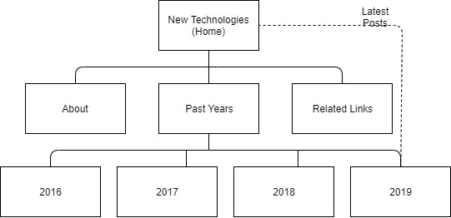

Рисунок 1 - Пример структурной схемы сайта «*New Technologies*»

## 2.1 Первая страница – «*About*»

Для выполнения данного задания в редакторе VS Code был создан документ *about.html*, который представлен в Приложении А. В данном документе были использованы различные виды заголовков, таблица и изображения, а также стили, представленные в приложении Б. Законченный вид веб-страницы можно увидеть на рисунках 2 и 3.

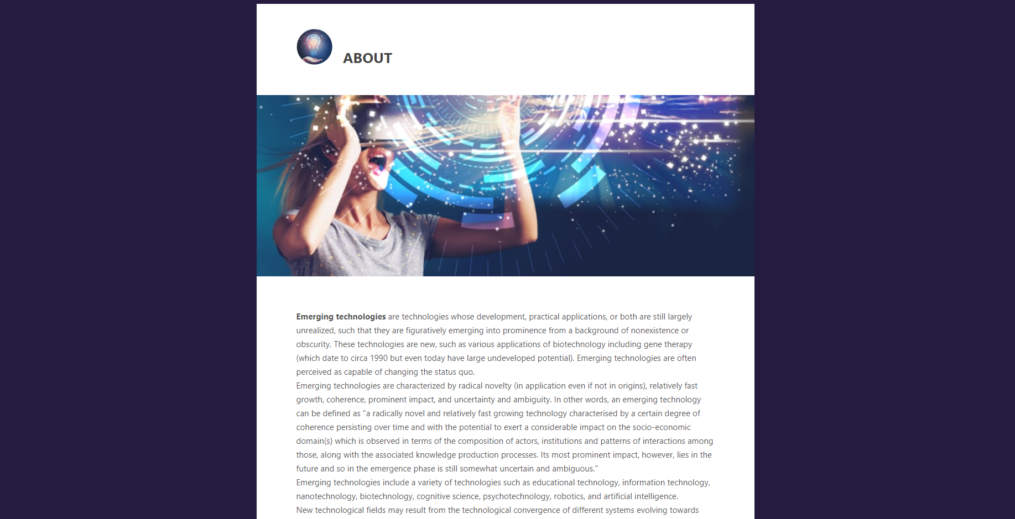

Рисунок 2 – Страница *«About»*

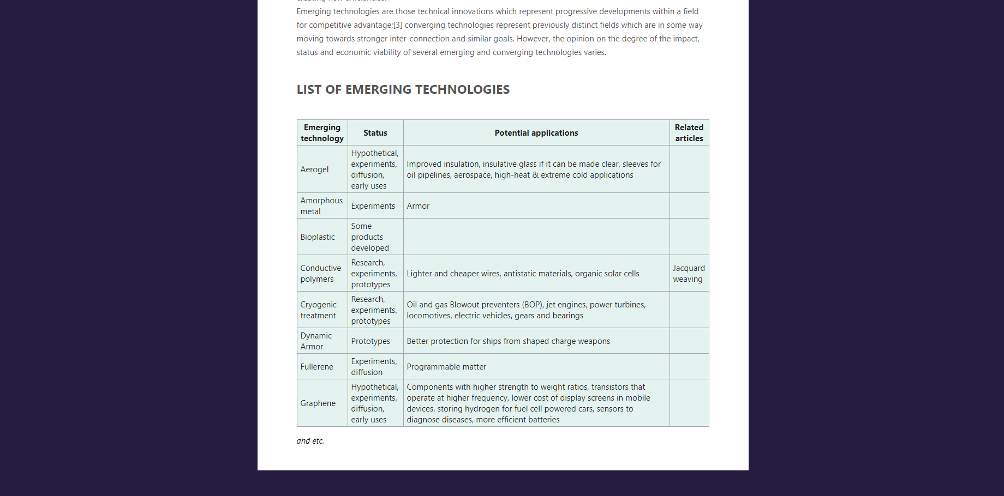

Рисунок 3 – Страница *«About»* (продолжение)

## 2.2 Освоение работы с различными типами ссылок. Форматирование символов. Вставка комментариев. Создание страницы с обзором новых технологий по годам

Данное задание было выполнено на страницах «*index.html*» и «*past_years.html*», которые представлены на рисунках 4 и 5. Например, блок «*Categories*» на странице «*index.html*»:

*<div class="widget-container">*

*<h6 class="widget-title">Categories</h6>*

*<ul>*

*<li><a href="about.html">About</a>*

*</li>*

*<li><a href="past_years.html">Past Years</a>*

*</li>*

*<li><a href="related_links.html">Related links</a>*

*</li>*

*</ul>*

*<div class="clear"></div>*

*</div>*

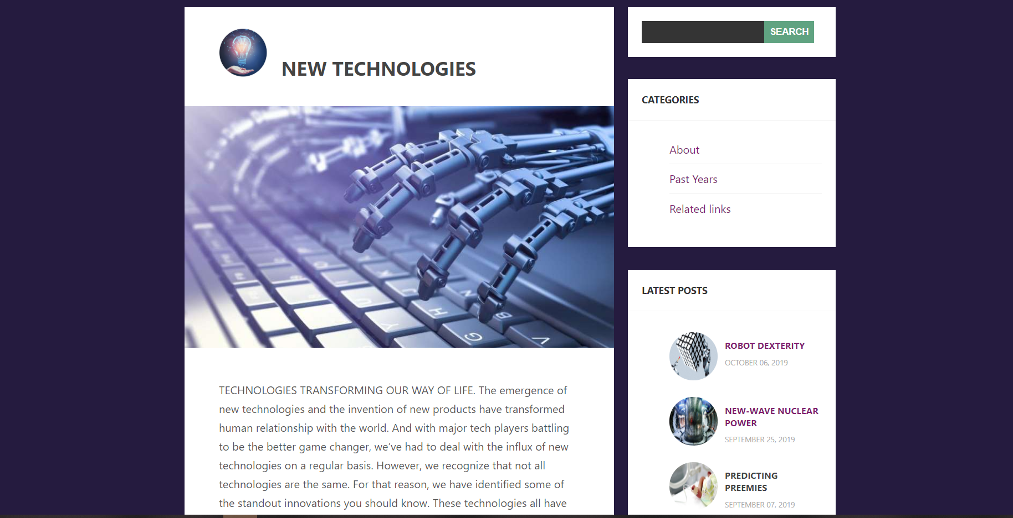

Рисунок 4 – Внешний вид домашней страницы («*index.html*»)

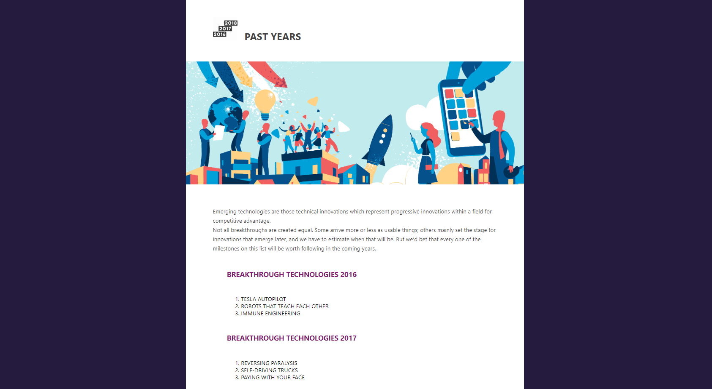

Рисунок 5 – Страница «*Past Years*»

## 2.3 Освоение приемов работы с изображениями. Форматирование текста, вставка комментариев. Использование блока <DIV> … </DIV>

Разметка всех страниц данного сайта построена на основе блоков *<div>…</div>*, за исключением страницы «*related_links.html*», где использованы фреймы. Работа с блоками продемонстрирована в приложении А, а с их стилями – в приложении Б.

## 2.4 Создание страниц «2016.html», «2017.html», «2018.html», «2019.html»

Все четыре страницы созданы по одному шаблону, с использованием одних и тех же стилей. Доступ к этим страницам осуществляется посредством перехода по ссылкам из непронумерованного списка из страницы «*past_years.html*». Листинг разметки представлен в приложении А.

## 2.5 Освоение приемов создания вложенных и комбинированных списков

Пример вложенных и комбинированных списков представлен на странице «*past_years.html*»:

*<ul>*

*<li>*

*<h6><b><a href="2016.html">Breakthrough Technologies 2016</a></b></h6>*

*<ol>*

*<li>TESLA AUTOPILOT</li>*

*<li>ROBOTS THAT TEACH EACH OTHER</li>*

*<li>IMMUNE ENGINEERING</li>*

*</ol>*

*</li>*

*<li>*

*<h6><b><a href="2017.html">Breakthrough Technologies 2017</a></b></h6>*

*<ol>*

*<li>REVERSING PARALYSIS</li>*

*<li>SELF-DRIVING TRUCKS</li>*

*<li>PAYING WITH YOUR FACE</li>*

*</ol>*

*</li>*

*<li>*

*<h6><b><a href="2018.html">Breakthrough Technologies 2018</a></b></h6>*

*<ol>*

*<li>3-D METAL PRINTING</li>*

*<li>ARTIFICIAL EMBRYOS</li>*

*<li>SENSING CITY</li>*

*</ol>*

*</li>*

*<li>*

*<h6><b><a href="2019.html">Breakthrough Technologies 2019</a></b></h6>*

*<ol>*

*<li>ROBOT DEXTERITY</li>*

*<li>NEW-WAVE NUCLEAR POWER</li>*

*<li>PREDICTING PREEMIES</li>*

*<li>GUT PROBE IN A PILL</li>*

*</ol>*

*</li>*

*</ul>*

Внешний вид списка можно наблюдать на рисунке 5. С помощью стилей убраны маркеры с неупорядоченного списка.

## 2.6 Освоение приемов работы с фреймами

Работа с фреймами проиллюстрирована в виде страницы «*related_links.html*», которая представляет собой список источников, которые использовались для создания данного веб-сайта. Листинг разметки представлен в приложении А.

## 2.7 Освоение табличного форматирования на примере страницы «*About*»

Пример табличного форматирования представлен на странице «*about.html»*, внешний вид которой находится на рисунке 3. Листинг разметки таблицы:

*<table class="techtable" border="1">*

*<tbody>*

*<tr>*

*<th>Emerging technology</th>*

*<th>Status</th>*

*<th>Potential applications</th>*

*<th>Related articles</th>*

*</tr>*

*<tr>*

*<td>Aerogel</td>*

*<td>Hypothetical, experiments, diffusion, early uses</td>*

*<td>Improved insulation, insulative glass if it can be made clear, sleeves for oil*

*pipelines, aerospace, high-heat &amp; extreme cold applications </td>*

*<td></td>*

*</tr>*

*<tr>*

*<td>Amorphous metal</td>*

*<td>Experiments</td>*

*<td>Armor</td>*

*<td></td>*

*</tr>*

*<tr>*

*<td>Bioplastic</td>*

*<td>Some products developed</td>*

*<td></td>*

*<td></td>*

*</tr>*

*<tr>*

*<td>Conductive polymers</td>*

*<td>Research, experiments, prototypes</td>*

*<td>Lighter and cheaper wires, antistatic materials, organic solar cells</td>*

*<td>Jacquard weaving</td>*

*</tr>*

*<tr>*

*<td>Cryogenic treatment</td>*

*<td>Research, experiments, prototypes </td>*

*<td>Oil and gas Blowout preventers (BOP), jet engines, power turbines, locomotives,*

*electric vehicles, gears and bearings</td>*

*<td> </td>*

*</tr>*

*<tr>*

*<td>Dynamic Armor</td>*

*<td>Prototypes</td>*

*<td>Better protection for ships from shaped charge weapons</td>*

*<td></td>*

*</tr>*

*<tr>*

*<td>Fullerene</td>*

*<td>Experiments, diffusion</td>*

*<td>Programmable matter</td>*

*<td></td>*

*</tr>*

*<tr>*

*<td>Graphene</td>*

*<td>Hypothetical, experiments, diffusion, early uses </td>*

*<td>Components with higher strength to weight ratios, transistors that operate at*

*higher frequency, lower cost of display screens in mobile devices, storing*

*hydrogen for fuel cell powered cars, sensors to diagnose diseases, more*

*efficient batteries</td>*

*<td></td>*

*</tr>*

*</tbody>*

*</table>*

## 2.8 Создание домашней страницы

Домашняя страница содержит в себе ссылки на страницы «*About*», «*Past Years*», «*Related Links*», а также ссылки на последние статьи со страницы «*2019*». Листинг разметки представлен в приложении А.

# 3 Вывод

В ходе лабораторной работы были изучены основные принципы работы с *HTML* и *CSS,* в результате которой был создан восьмистраничный веб-сайт на тему «Новые технологии». В разметке данного сайта были использованы ссылки, вложенные и комбинированные списки, форматирование текста, заголовки нескольких уровней, блоки, таблицы и фреймы. Стили дали возможность представить разметку в более удобном варианте. Как результат – приятное и читабельное «безбумажное» отображение информации.

**Приложение А  
(обязательное)  
Листинг разметки веб-сайта**

**Разметка «*about.html*»**

*<!DOCTYPE html>*

*<head>*

*<meta http-equiv="Content-Type" content="text/html; charset=utf-8" />*

*<title> New technologies</title>*

*</head>*

*<link rel="stylesheet" href="styles.css" type="text/css">*

*<body>*

*<div class="about">*

*<div class="about-column" id="post-container">*

*<div class="wrap-col">*

*<div class="post">*

*<div class="post-margin">*

*<div class="post-avatar">*

*<div class="avatar-frame"></div>*

*<img alt='' src="images/logo.jpg" height="70" width="70" />*

*</div>*

*<h4 class="post-title">About</h4>*

*<div class="clear"></div>*

*</div>*

*<div class="main-image">*

*<img src="images/july-9-bottom-pic.jpg" id="main-imgs" />*

*</div>*

*<div class="post-margin">*

*<p><b>Emerging technologies</b> are technologies whose development, practical*

*applications, or both are still largely unrealized, such that they are figuratively emerging*

*into prominence from a background of nonexistence or obscurity.*

*These technologies are new, such as various applications of biotechnology including gene*

*therapy (which date to circa 1990 but even today have large undeveloped potential).*

*Emerging technologies are often perceived as capable of changing the status quo.*

*<br>Emerging technologies are characterized by radical novelty (in application even if not*

*in origins), relatively fast growth, coherence, prominent impact, and uncertainty and*

*ambiguity.*

*In other words, an emerging technology can be defined as "a radically novel and relatively*

*fast growing technology characterised by a certain degree of coherence persisting over time*

*and with the potential to exert*

*a considerable impact on the socio-economic domain(s) which is observed in terms of the*

*composition of actors, institutions and patterns of interactions among those, along with the*

*associated knowledge production processes.*

*Its most prominent impact, however, lies in the future and so in the emergence phase is*

*still somewhat uncertain and ambiguous."*

*<br>Emerging technologies include a variety of technologies such as educational technology,*

*information technology, nanotechnology, biotechnology, cognitive science, psychotechnology,*

*robotics, and artificial intelligence.*

*<br>New technological fields may result from the technological convergence of different*

*systems evolving towards similar goals. Convergence brings previously separate technologies*

*such as voice (and telephony features),*

*data (and productivity applications) and video together so that they share resources and*

*interact with each other, creating new efficiencies.*

*<br>Emerging technologies are those technical innovations which represent progressive*

*developments within a field for competitive advantage;[3] converging technologies represent*

*previously distinct fields which are in some way moving towards stronger inter-connection*

*and similar goals. However, the opinion*

*on the degree of the impact, status and economic viability of several emerging and*

*converging technologies varies.</p>*

*<h5><b>List of emerging technologies</b></h5>*

*<table class="techtable" border="1">*

*<tbody>*

*<tr>*

*<th>Emerging technology</th>*

*<th>Status</th>*

*<th>Potential applications</th>*

*<th>Related articles</th>*

*</tr>*

*<tr>*

*<td>Aerogel</td>*

*<td>Hypothetical, experiments, diffusion, early uses</td>*

*<td>Improved insulation, insulative glass if it can be made clear, sleeves for oil*

*pipelines, aerospace, high-heat &amp; extreme cold applications </td>*

*<td></td>*

*</tr>*

*<tr>*

*<td>Amorphous metal</td>*

*<td>Experiments</td>*

*<td>Armor</td>*

*<td></td>*

*</tr>*

*<tr>*

*<td>Bioplastic</td>*

*<td>Some products developed</td>*

*<td></td>*

*<td></td>*

*</tr>*

*<tr>*

*<td>Conductive polymers</td>*

*<td>Research, experiments, prototypes</td>*

*<td>Lighter and cheaper wires, antistatic materials, organic solar cells</td>*

*<td>Jacquard weaving</td>*

*</tr>*

*<tr>*

*<td>Cryogenic treatment</td>*

*<td>Research, experiments, prototypes </td>*

*<td>Oil and gas Blowout preventers (BOP), jet engines, power turbines, locomotives,*

*electric vehicles, gears and bearings</td>*

*<td> </td>*

*</tr>*

*<tr>*

*<td>Dynamic Armor</td>*

*<td>Prototypes</td>*

*<td>Better protection for ships from shaped charge weapons</td>*

*<td></td>*

*</tr>*

*<tr>*

*<td>Fullerene</td>*

*<td>Experiments, diffusion</td>*

*<td>Programmable matter</td>*

*<td></td>*

*</tr>*

*<tr>*

*<td>Graphene</td>*

*<td>Hypothetical, experiments, diffusion, early uses </td>*

*<td>Components with higher strength to weight ratios, transistors that operate at*

*higher frequency, lower cost of display screens in mobile devices, storing*

*hydrogen for fuel cell powered cars, sensors to diagnose diseases, more*

*efficient batteries</td>*

*<td></td>*

*</tr>*

*</tbody>*

*</table>*

*<i>and etc.</i>*

*</div>*

*<div class="clear"></div>*

*</div>*

*<div class="clear"></div>*

*</div>*

*</div>*

*</div>*

*</div>*

*<div class="clear"></div>*

*</div>*

*</body>*

**Разметка «*past_years.html*»**

*<!DOCTYPE html>*

*<head>*

*<meta http-equiv="Content-Type" content="text/html; charset=utf-8" />*

*<title> New technologies</title>*

*</head>*

*<link rel="stylesheet" href="styles.css" type="text/css">*

*<body>*

*<div class="about">*

*<div class="about-column" id="post-container">*

*<div class="wrap-col">*

*<div class="post">*

*<div class="post-margin">*

*<div class="post-avatar">*

*<div class="avatar-frame"></div>*

*<img alt='' src="images/xxx038-512.png" height="70" width="70" />*

*</div>*

*<h4 class="post-title">Past Years</h4>*

*<div class="clear"></div>*

*</div>*

*<div class="main-image">*

*<img src="images/Future-of-Technology-2019.png" id="main-imgs" />*

*</div>*

*<div class="post-margin">*

*<p>Emerging technologies are those technical innovations which represent progressive*

*Innovations within a field for competitive advantage.*

*<br>Not all breakthroughs are created equal. Some arrive more or less as usable things;*

*others mainly set the stage for innovations that emerge later, and we have to estimate when*

*that will be. But we’d bet that every one of the milestones on this list will be worth*

*following in the coming years.*

*</p>*

*<ul>*

*<li>*

*<h6><b><a href="2016.html">Breakthrough Technologies 2016</a></b></h6>*

*<ol>*

*<li>TESLA AUTOPILOT</li>*

*<li>ROBOTS THAT TEACH EACH OTHER</li>*

*<li>IMMUNE ENGINEERING</li>*

*</ol>*

*</li>*

*<li>*

*<h6><b><a href="2017.html">Breakthrough Technologies 2017</a></b></h6>*

*<ol>*

*<li>REVERSING PARALYSIS</li>*

*<li>SELF-DRIVING TRUCKS</li>*

*<li>PAYING WITH YOUR FACE</li>*

*</ol>*

*</li>*

*<li>*

*<h6><b><a href="2018.html">Breakthrough Technologies 2018</a></b></h6>*

*<ol>*

*<li>3-D METAL PRINTING</li>*

*<li>ARTIFICIAL EMBRYOS</li>*

*<li>SENSING CITY</li>*

*</ol>*

*</li>*

*<li>*

*<h6><b><a href="2019.html">Breakthrough Technologies 2019</a></b></h6>*

*<ol>*

*<li>ROBOT DEXTERITY</li>*

*<li>NEW-WAVE NUCLEAR POWER</li>*

*<li>PREDICTING PREEMIES</li>*

*<li>GUT PROBE IN A PILL</li>*

*</ol>*

*</li>*

*</ul>*

*</div>*

*<div class="clear"></div>*

*</div>*

*<div class="clear"></div>*

*</div>*

*</div>*

*</div>*

*</div>*

*<div class="clear"></div>*

*</div>*

*</body>*

**Разметка «*related_links.html*»**

*<!DOCTYPE HTML PUBLIC "-//W3C//DTD HTML 4.01 Frameset//EN" "http://www.w3.org/TR/html4/frameset.dtd">*

*<html>*

*<head>*

*<meta http-equiv="Content-Type" content="text/html; charset=utf-8">*

*<title>Related Links</title>*

*</head>*

*<frameset cols="50%, 50%">*

*<frame src="https://www.technologyreview.com/" name="Frame 1">*

*<frame src="https://www.euronews.com/tag/new-technologies" name="Frame 2">*

*</frameset>*

*</html>*

**Разметка «*2016.html*» (неполная)**

*<!DOCTYPE html>*

*<head>*

*<meta http-equiv="Content-Type" content="text/html; charset=utf-8" />*

*<title> New technologies</title>*

*</head>*

*<link rel="stylesheet" href="styles.css" type="text/css">*

*<body>*

*<div class="banner">*

*<img class="banner-image" src="images/guest-blogger-2016-tech-trends-maving-waves.jpg" alt="" />*

*</div>*

*<div class="about">*

*<div class="about-column" id="post-container">*

*<div class="wrap-col">*

*<div class="post">*

*<div class="post-margin">*

*<div class="post-avatar">*

*<div class="avatar-frame"></div>*

*<img alt='' src="images/logo.jpg" height="70" width="70" />*

*</div>*

*<h4 class="post-title">Tesla Autopilot</h4>*

*<div class="clear"></div>*

*</div>*

*<div class="main-image">*

*<img src="images/ma16-10tesla-1.jpg" id="main-imgs" />*

*</div>*

*<div class="post-margin">*

*<p><b>In October 2014, Elon Musk’s electric-car company began rolling out</b> sedans with*

*A dozen ultrasonic sensors discreetly placed around both bumpers and sides.*

*For an additional $4,250, Tesla customers could purchase a “technology package” that used*

*the sensors, as well as a camera, a front radar, and digitally controlled brakes, to help*

*avoid collisions—essentially allowing the car to take over and stop before crashing. But*

*mostly, the hardware sat there, waiting, waiting, and gathering reams of data. A year later,*

*last October 14, the company sent a software update to the 60,000 sensor-laden cars it had*

*sold in that time.*

*The software update was officially named Tesla Version 7.0, but its nickname—Autopilot—*

*Was what stuck.*

*<br>It did in fact give drivers something similar to what airline pilots employ in flight.*

*The car could manage its speed, steer within and even change lanes, and park itself. Some of*

*these features, like automatic parallel parking, were already on offer from other car*

*companies (including Mercedes, BMW, and General Motors), but the self-steering was*

*suddenly, overnight, via a software update, a giant leap toward full autonomy.*

*<br>*

*<br>Tesla customers, delighted, posted videos of themselves on the highway, hands free,*

*reading the paper, sipping coffee, and even, once, riding on the roof. Some of these are,*

*it’s worth pointing out, illegal acts. Autopilot existed in a legal gray area, but it was a*

*grand gesture toward an ever nearing future, one that will reshape not just the car and our*

*relationship with it but the road and our entire transportation infrastructure.*

*<br>*

*<br>Which is why I jumped at the chance to borrow a car with Autopilot for a few days and*

*drive it—or let it drive me—around Los Angeles.*

*<br>Everyone wanted to know what it felt like, the strange surrender of allowing a car to*

*take control. The only moments that seemed like magic were when the car parked itself or*

*changed lanes, mostly because watching a steering wheel turn all on its own was unnatural*

*and ghostly. Other than that, I was amazed by how quickly I got used to it, how inevitable*

*it began to feel. As a Tesla engineer told me—on condition of anonymity, because the*

*company won’t let anyone but Musk speak publicly these days—the thing that quickly becomes*

*strange is driving a car without Autopilot. “You’ll feel like the car is not doing its job,” he*

*said.*

*<br>The car can’t start in Autopilot; it requires a set of circumstances (good data,*

*basically) before you can engage the setting. These include clear lane lines, a relatively*

*constant speed, a sense of the cars around you, and a map of the area you’re traveling*

*through—roughly in that order. L.A.’s abundant highway traffic is the ideal scenario for*

*Autopilot, not simply because of all the data it makes available to the ultrasonic*

*sensors—which use high-frequency sound waves to identify objects up to 16 feet away—but*

*also because humans are awful in traffic. We are bad at estimating distances to begin with,*

*and we are constantly trying to switch lanes when the next one looks faster, causing accidents*

*in the process. With Autopilot, I no longer had to stare at the bumper ahead of me, and I*

*could look around to see the variety of bad decisions drivers make, stopping and starting*

*and stopping again. Meanwhile, my car accelerated and slowed more smoothly than it ever*

*could have with me in charge.*

*<br>With its incremental approach, Tesla stands in contrast to Google and other companies*

*that have small test fleets gathering data in hopes of someday launching fully autonomous*

*cars. For Tesla, its customers and their partially autonomous cars are a widely distributed*

*test fleet. The hardware required for true autonomy is already in place, so the transition*

*can play out in software updates. Musk has said that could be technically feasible—if not*

*legally so—within two years.*

*<br>*

*<br>The day after I returned the Tesla, my fiancée and I were on an L.A. freeway and saw*

*someone, speeding, cross three lanes, cutting in front of several drivers. As the traffic*

*stopped, the car behind us came in way too fast and crashed into our bumper, which fell*

*right off. The future, I thought, was practically here, and it couldn’t arrive soon enough.*

*</p>*

*</div>*

*<div class="clear"></div>*

*</div>*

*<div class="clear"></div>*

*</div>*

*</div>*

*</div>*

*</div>*

Разметки «*2017.html*», «*2018.html*», «*2019.html*» аналогичны разметке «*2016.html*».

**Разметка «*index.html*»**

*<!DOCTYPE html>*

*<head>*

*<meta http-equiv="Content-Type" content="text/html; charset=utf-8" />*

*<title> New technologies</title>*

*</head>*

*<link rel="stylesheet" href="styles.css" type="text/css">*

*<body>*

*<div class="container main">*

*<div class="col-2-3" id="post-container">*

*<div class="wrap-col">*

*<div class="post">*

*<div class="post-margin">*

*<div class="post-avatar">*

*<div class="avatar-frame"></div>*

*<img alt='' src="images/logo.jpg" height="70" width="70" />*

*</div>*

*<h4 class="post-title">New Technologies</h4>*

*<div class="clear"></div>*

*</div>*

*<div class="main-image">*

*<img src="images/main.jpg" id="main-imgs" />*

*</div>*

*<div class="post-margin">*

*<p>TECHNOLOGIES TRANSFORMING OUR WAY OF LIFE.*

*The emergence of new technologies and the invention of new products have transformed*

*Human relationship with the world.*

*And with major tech players battling to be the better game changer, we’ve had to deal with*

*the influx of new technologies on a regular basis.*

*However, we recognize that not all technologies are the same.*

*For that reason, we have identified some of the standout innovations you should know.*

*These technologies all have staying power.*

*They will affect the economy and our politics, improve medicine, or influence our culture.*

*Some are unfolding now; others will take a decade or more to develop.*

*But you should know about all of them right now.</p>*

*</div>*

*<div class="clear"></div>*

*</div>*

*<div class="clear"></div>*

*</div>*

*</div>*

*<div class="col-1-3">*

*<div class="wrap-col">*

*<div class="widget-container">*

*<form role="search" method="get" id="searchform" class="searchform" action="">*

*<div>*

*<label class="screen-reader-text" for="s">Search for:</label>*

*<input type="text" value="" name="s" id="s" />*

*<input type="submit" id="searchsubmit" value="Search" />*

*</div>*

*</form>*

*<div class="clear"></div>*

*</div>*

*<div class="widget-container">*

*<h6 class="widget-title">Categories</h6>*

*<ul>*

*<li><a href="about.html">About</a>*

*</li>*

*<li><a href="past_years.html">Past Years</a>*

*</li>*

*<li><a href="related_links.html">Related links</a>*

*</li>*

*</ul>*

*<div class="clear"></div>*

*</div>*

*<div class="widget-container">*

*<h6 class="widget-title">Latest Posts</h6>*

*<ul class="widget-recent-posts">*

*<li>*

*<div class="post-image">*

*<div class="post-mask"></div>*

*<img width="70" height="70" src="images/ma19tr102.jpg" class="round" />*

*</div>*

*<h6><a href="2019.html#robot_dexterity" target=_blank>Robot dexterity</a></h6>*

*<span>October 06, 2019</span>*

*<div class="clear"></div>*

*</li>*

*<li>*

*<div class="post-image">*

*<div class="post-mask"></div>*

*<img width="70" height="70" src="images/c-mod-internal-1.jpg" class="round" />*

*</div>*

*<h6><a href="2019.html#nuclear_power" target=_blank>New-wave nuclear power</a></h6>*

*<span>September 25, 2019</span>*

*<div class="clear"></div>*

*</li>*

*<li>*

*<div class="post-image">*

*<div class="post-mask"></div>*

*<img width="70" height="70" src="images/gettyimages-579186884.jpg" class="round" />*

*</div>*

*<h6><a href="2019.html#preemies" target=_blank>Predicting preemies</a></h6>*

*<span>September 07, 2019</span>*

*<div class="clear"></div>*

*</li>*

*<li>*

*<div class="post-image">*

*<div class="post-mask"></div>*

*<img width="70" height="70" src="images/ma19tr104.2.jpg" class="round" />*

*</div>*

*<h6><a href="2019.html#pill" target=_blank>Gut probe in a pill</a></h6>*

*<span>August 25, 2019</span>*

*<div class="clear"></div>*

*</li>*

*</ul>*

*<div class="clear"></div>*

*</div>*

*<div class="clear"></div>*

*</div>*

*</div>*

*<div class="clear"></div>*

*</div>*

*</body>*

**Приложение Б  
(обязательное)  
Листинг стилей веб-сайта**

*body{*

*background:#251b3f;*

*font-family: 'Segoe UI', Tahoma, Geneva, Verdana, sans-serif;*

*padding-bottom:30px;*

*}*

*h1,h2,h3,h4,h5,h6{ font-family: 'Segoe UI', Tahoma, Geneva, Verdana, sans-serif; text-transform:uppercase; font-weight:700; line-height:1.4em; color:#555555; }*

*h1{ font-size:35px; }*

*h2{ font-size:33px; }*

*h3{ font-size:30px; }*

*h4{ font-size:28px; }*

*h5{ font-size:25px; }*

*h6{ font-size:20px; }*

*.banner{width: 100%; display: block;}*

*.banner .banner-image{ width: 100%}*

*p{ font-size:16px; line-height:1.7em; color:#555555; margin-bottom:20px; }*

*a{ color:#444444; text-decoration:none; }*

*a:hover{ color:#31af91; }*

*a:visited { color: #821e6f; }*

*a:active { color: #f1616e; }*

*.techtable {*

*background-color: #e5f3f0;*

*color: #222;*

*margin: 1em 0;*

*border: 1px solid #a2a9b1;*

*border-collapse: collapse;*

*}*

*thead {*

*display: table-header-group;*

*vertical-align: middle;*

*border-color: inherit;*

*}*

*table {*

*border-collapse: separate;*

*border-spacing: 2px;*

*}*

*td {*

*display: table-cell;*

*vertical-align: inherit;*

*}*

*.techtable > tr > th, .techtable > tr > td, .techtable > * > tr > th, .techtable > * > tr > td {*

*border: 1px solid #a2a9b1;*

*padding: 0.2em 0.4em;*

*}*

*.clear{ clear: both; }*

*.wrapper{ width:100%; }*

*.first{ margin-left:0px; }*

*.last{ margin-right:0px; }*

*.spacing-10{ height:10px; width:100%; }*

*.spacing-20{ height:20px; width:100%; }*

*.spacing-30{ height:30px; width:100%; }*

*.spacing-40{ height:40px; width:100%; }*

*.spacing-50{ height:50px; width:100%; }*

*.spacing-60{ height:60px; width:100%; }*

*.spacing-70{ height:70px; width:100%; }*

*.spacing-80{ height:80px; width:100%; }*

*.spacing-90{ height:90px; width:100%; }*

*.spacing-100{ height:100px; width:100%; }*

*.post{*

*background:#FFFFFF;*

*margin-bottom:40px;*

*}*

*.post .post-margin{ padding-left:8%; padding-right:8%; padding-top:5%; padding-bottom:5%; }*

*.post .post-title{ margin-bottom:5px; color:#444444; }*

*.post-avatar{ height:70px; width:70px; float:left; margin-right:20px; }*

*.post-avatar .avatar-frame{ border-radius: 70px; height:70px; width:70px; position:absolute; }*

*.post .readmore{ text-transform:uppercase; font-weight:700; text-align: center;}*

*.post .readmore img {margin-left: 5px;}*

*.post .main-image{ width:100%; height:350px; }*

*.post .main-image img{ width:100%; height:350px; object-fit: cover;}*

*.post .main-image iframe{ width:100%; height:343px; }*

*.post .post-icon{ width:80px; height:80px; position:relative; bottom:40px; margin:0 auto; z-index:1000 }*

*.post-icon .fa-stack{ height:80px; width:80px; font-size:40px; }*

*.post-icon .fa-picture-o{ font-size:30px; }*

*.post-icon .fa-circle{ color:#FFFFFF; }*

*.post-icon .fa-inverse{ color:#31af91; }*

*ul{*

*list-style: none;*

*}*

*.widget-container{ background:#FFFFFF; margin-bottom:30px; padding-bottom:20px; }*

*.widget-title{*

*padding:20px;*

*padding-bottom:20px;*

*font-size:14px;*

*color:#343434;*

*border-bottom:1px solid #EEEEEE;*

*margin-bottom:20px;*

*}*

*.widget-container ul{ margin-left:20px; margin-right:20px; font-size:16px; }*

*.widget-container li{ border-bottom:1px solid #EEEEEE; padding-bottom:10px; padding-top:10px; }*

*.widget-container li:first-child{ border-top:none; }*

*.widget-container li:last-child{ border-bottom:none; }*

*.widget-container .searchform div{ padding:20px; margin-bottom:0px; }*

*.widget-container .searchform label{ display:none; }*

*.widget-container .searchform input{ outline:none; }*

*.widget-container .searchform #s{ padding:10px; padding-top:8px; padding-bottom:8px; margin-right:0px; float:left; background:#343434; color:#FFFFFF; border:none; }*

*.widget-container .searchform #searchsubmit{ margin-left:0px; float:left; padding:8px; padding-left:8px; padding-right:8px; text-transform:uppercase; font-weight:700; }*

*.widget-container .searchform #searchsubmit{ background:#60a381;; border:none; color:#FFFFFF; }*

*.widget-container p{ margin-left:20px; margin-right:20px; font-size:14px; }*

*.widget-container ul{ margin-left:20px; margin-right:20px; font-size:16px; }*

*.widget-container li{ border-bottom:1px solid #EEEEEE; padding-bottom:10px; padding-top:10px; }*

*.widget-container li:first-child{ border-top:none; }*

*.widget-container li:last-child{ border-bottom:none; }*

*.widget-recent-posts li{ border-bottom:none; margin-bottom:0px; }*

*.widget-recent-posts h6{ font-size:13px; margin-top:10px; margin-bottom:3px; }*

*.widget-recent-posts span{ font-size:11px; color:#AAAAAA; text-transform:uppercase; }*

*.widget-recent-posts .post-image{ float:left; margin-right:10px }*

*.widget-recent-posts .post-image .post-mask{ height:70px; width:70px; border-radius: 70px; position:absolute }*

*.round{*

*border-radius: 70px;*

*}*

*.avatar-mask{ height:70px; width:70px; border-radius: 70px;border: 3px solid green; position:absolute }*

*.avatar-container{ float:left; margin-right:20px; }*

*.about{ display: block;justify-content: center; }*

*.about-column{ width: 960px; margin: 0 auto;}*

*.main{ width: 960px; position: relative; margin: 0 auto; padding: 0px;}*

*.main:after { content: "\0020"; display: block; height: 0; clear: both; visibility: hidden; }*

*.main .row{}*

*.main .row:before,.row:after { content: '\0020'; display: block; overflow: hidden; visibility: hidden; width: 0; height: 0; }*

*.main .row:after{clear: both; }*

*.main .row{zoom: 1;}*

*.main .wrap-col{margin:10px;}*

*.main .col-1-2, .main .col-1-3, .main .col-2-3, .main .col-1-4, .main .col-2-4, .main .col-3-4, .main .col-1-5, .main .col-2-5, .main .col-3-5, .main .col-4-5, .main .col-1-6, .main .col-2-6, .main .col-3-6, .main .col-4-6, .main .col-5-6{*

*float:left; display: inline-block;}*

*.main .col-full{width:100%;}*

*.main .col-1-2{width:50%;}*

*.main .col-1-3{width:33.33%;}*

*.main .col-2-3{width:66.66%;}*

*.main .col-1-4{width:25%;}*

*.main .col-2-4{width:50%;}*

*.main .col-3-4{width:75%;}*

*.main .col-1-5{width:20%;}*

*.main .col-2-5{width:40%;}*

*.main .col-3-5{width:60%;}*

*.main .col-4-5{width:80%;}*

*.main .col-1-6{width:16.66%;}*

*.main .col-2-6{width:33.33%;}*

*.main .col-3-6{width:50%;}*

*.main .col-4-6{width:66.66%;}*

*.main .col-5-6{width:83.33%;}*